**A PROJECT REPORT**

**ON**

##### "E-BOOK WEBSITE"

**SUBMITTED TO**

###### SHIVAJI UNIVERSITY, KOLHAPUR

**For partial fulfillment of**

“Bachelor of Computer Application”

**SUBMITTED BY**

MR. SHUBHAM SHIVAJI MENGANE.(B.C.A –II)

MR. OMKAR SURESH GAVLI.(B.C.A –II)

**UNDER THE GUIDANCE OF Prof. Miss. P.B.PATEKARI. (M.C.A.) THROUGH**

**The Principal**

**SHIVRAJ COLLEGE OF ARTS , COMMERCE & D.S.KADAM SCIENCE COLLEGE, GADHINGLAJ DIST.KOLHAPUR 2021 – 2022**

**K.V.R. Shinde Shikshan Sanstha’s**

**Shivraj College of Arts, Commerce And**

**D. S. Kadam Science College, Gadhinglaj. (Dist. Kolhapur)**

Certificate



This is to certify that **Mr. Shubham Shivaji mengane or Mr. Omkar Suresh Gavli** has successfully completed the project on the topic **“E-Book Website”** in satisfactory manner for partial fulfillment of degree for the academic year 2021- 22.

To the best of our knowledge and belief the matter presented here is original and has not been submitted elsewhere for the award of any degree.

Place: Gadhinglaj Date:

Examiner

Prof. K. S. Desai (H.O.D)

**K.V.R. Shinde Shikshan Sanstha’s**

##### Shivraj College of Arts, Commerce And

**D. S. Kadam Science College, Gadhinglaj. (Dist. Kolhapur)**

Certificate



This is to certify that the project entitled **“E-Book Website”** submitted by **Mr. Shubham Shivaji Mengane or Mr. Omkar Suresh Gavli**. To partial fulfillment of the requirement of degree of B.C.A. has been prepared under my guidance and supervision in their original work.

To the best of my knowledge and belief, no such work has been previously submitted to the award of any degree in past and is an original work.

Place: Gadhinglaj Date:

Prof. Miss. P.B.Patekari. (Project Guide)

# DECLARATION

We, undersigned hereby declare that this report entitled

**“E-Book Website”** is original work prepare by us under guidance of *Prof. Miss. P.B.Patekari*.

The empirical finding in this reports are based on data collected by us . The matter presented in this report is not copied from any source.

We, understand that any such copy is liable for punishment in any way the University Authorities deem to fit. This work has not been submitted previously to the award of degree to Shivaji University, Kolhapur or any other University.

This work is humbly submitted to Shivaji University for the award of the degree of Bachelor of Computer Application (B.C.A).

Place :- Gadhinglaj. Date :-

*Mr. Shubham Shivaji Menagne .*

*Mr. Omkar Suresh Gavli .*

**ACKNOWLEDGEMENT**

For the completion of our project we took support and inspiration from lot of people. With their valuable support and suggestions, we are completed this project within time successfully. It gives us great pleasure to remain deeply indebted to our guide Miss.P.B.Patekari. under whom we had the privilege to work.

We also take this opportunity to express our gratitude to head of department Prof. Mr. Desai K.S. for providing our with the required facilities for the academic achievement.

We wish to record my sincere obligation to our parents for encouraging me to take up this course and also proceeding continuous financial assistance to for enabling to undergo this course and completion of the project.

Finally we are thankful all of them who have contributed either directly or indirectly to this project.

Thanking you,

*Mr. Shubham Shivaji Mengane.*

*Mr. Omkar Suresh Gavli.*

***INDEX***

|  |  |  |
| --- | --- | --- |
| ***Sr.No.*** | ***TITLE*** | ***Page No*** |
| **1.** | **Introduction to project**   * About HTML & CSS * About Project * Objectives | 7 - 9 |
| **2.** | **Software & Hardware Requirement**   * Hardware & Software requirement | 10 - 11 |
| **3.** | **Existing System & Proposed System**   * Existing System * Proposed System | 12 – 13 |
| **4.** | **System Design**   * Coding * Output screen | 14 – 35 |
| **5.** | **Application And Conclusion**   * Application * Conclusion | 37 – 38 |
|  | * Bibliography | 39 |

**ABOUT HTML & CSS**

HTML is tag-based language used to

#### develop of web pages. HTML stands for Hyper Text Markup Language. Hypertext refers to the way in which web pages are linked together. Thus the link available on web page is called Hypertext. It is a markup language which is tags tell the browser how the page will be rendered on it.

CSS, or “Cascading Style Sheets,” is used for styling and laying out webpages. It can be used to adjust content size, spacing, color and font or add decorative features, such as animations or split content into columns.

## ABOUT PROJECT

This Website is mainly developed by using “HTML, JAVA SCRIPT, & CSS”.

E-book is very useful for book readers. The book is on server so you can access them any time and anywhere.

This E-book website saves your time and money and it is available at any place 24/7.

With the help of E-book the reader can read a book according to his time.

## OBJECTIVES

1. To make user friendly platform for book readers.
2. To avoid a struggle of getting books by libraries and book stalls.
3. To get books it is open and free.
4. To give 24/7 service to users.

**HARDWARE AND SOFTWARE REQUIREMENTS**

To run the software we must have certain hardware and software installed on our computer. The minimum system requirements includes :

### Software Requirements

* **Technology** :- Sublime Code Editor
* **Operating System** :- Windows10

### Hardware Requirements

###### MONITOR :-

*It displays information about the current work going on screen.*

*E.g. transaction, searching information etc.*

###### MOUSE :-

*It points on the screen where the user wants feed information Or an a certain point on the screen.*

###### KEYBOARD :-

*It gives the input to the computer from the outside world Or the information gives by a certain user.*

###### MEMORY :-

*4 GB RAM And 40 GB Hard Disk.*

Existing System

1. In the Existing system reader have to go to libraries for getting book.
2. Going to the book stalls and buying the book which is time and money consumer.
3. Every time the readers have to go libraries to get books for some time interval and giving back to libraries.

Proposed System

1. The proposed system is an E-book website.
2. On this platform the user get the book which he/she needed.
3. It is time and money saver for readers.
4. It is available 24/7 to user.
5. Because of E-book the user does not have carry heavy book any where.

# SOURCE CODE

HTML Code Of Home Page :-

<!DOCTYPE html>

<html lang="en">

<head>

<meta charset="UTF-8">

<meta name="viewport" content="width=device-width, initial-scale=1.0">

<title>E-book</title>

<link rel="stylesheet" type="text/css" href="style2.css">

</head>

<body background="C:\Users\SidivinayakAnganwadi\Desktop\mini project\e-books\2020-m0014-m007-m050-asym-m008-m022-ereaderguide-easyreading-as341000421.jpg"

style="background-repeat: no-repeat; background-size: 210vh 100vh;">

<div id="container">

<div id="background"></div>

<div id="navbar">

<ul>

<a style="color:#2c7ad6 ; font-size: 40px;">📚E-BOOKS</a>

<li><a href="file:///C:/Users/SidivinayakAnganwadi/Desktop/mini%20project/e-books/homepage.html">Home</a></li>

<div class="dropdown">

<button class="dropbtn" style="font-family:castellar; text-align: right; font-size: 35px;">BOOKS

<i class="fa fa-caret-down"></i>

</button>

<div class="dropdown-content">

<a href="file:///C:/Users/SidivinayakAnganwadi/Desktop/mini%20project/e-books/acadmic%20and%20education.html" style="font-family:castellar; text-align: right; font-size: 35px;">EDUCATIONAL BOOKS</a>

<br>

<a href="file:///C:/Users/SidivinayakAnganwadi/Desktop/mini%20project/e-books/historical.html" style="font-family:castellar; text-align: right; font-size: 35px;">BIOGRAPHY BOOKS</a>

<br>

<a href="file:///C:/Users/SidivinayakAnganwadi/Desktop/mini%20project/e-books/1page.html" style="font-family:castellar; text-align: right; font-size: 35px;">MORE</a>

</div>

</div>

<li><a href="file:///C:/Users/SidivinayakAnganwadi/Desktop/mini%20project/e-books/contactus.html?text=++++++++++++++++++++xgb%0D%0A++++++++++++++++++&submit=Submit">CONTACT US</a></li>

<li><a href="">GALLERY</a></li>

<li><a href="file:///C:/Users/SidivinayakAnganwadi/Desktop/mini%20project/e-books/aboutus.html">ABOUT US</a></li>

<li><a href="file:///C:/Users/SidivinayakAnganwadi/Desktop/mini%20project/e-books/stars.html">FEEDBACK</a></li>

</ul>

</div>

<div class="book">

<span class="page turn">

</span>

<span class="page turn">

</span>

<span class="page turn">

</span>

<span class="page turn">

</span>

<span class="page turn">

</span>

<span class="page turn">

</span>

<span class="cover">

</span>

<span class="page">

</span>

<span class="cover turn"></span>

</div>

</html>

CSS Home Page :-

<style>

#background{

min-height: 1050px;

width: 100%;

}

@media screen and (max width: 480px) {

.text{

font-size: 30px;

}

}

#top{

height: 35px;

width: 100%;

background:#2c7ad6;

line-height: 35px;

padding: 0px 20px 9px 100px;

box-sizing: border-box;

word-spacing:10px ;

}

#menu{

height:100px;

width: 100%;

background:lightblue;

align-self: center;

}

#logo{

height: 80px;

width: 60%;

background:lightblue;

text-align: left;

line-height: 65px;

font-size: 40px;

float: left;

}

#menu1{

height: 65px;

width: 100%;

background:lightblue;

float: left;

}

#menu1 UL{

list-style: none;

padding-left: 200px;

box-sizing: border-box;

margin: 15px;

}

#menu1 LI{

height: 50px;

width: 130px;

text-align: right;

display: inline-block;

line-height: 45px;

transform: translateY(-5px);

color: black;

font-size: 20px;

}

#menu1 LI:hover{

background: #2c7ad6;

color: white;

border-radius: 3px;

}

#navbar {

height: 90px;

width: 100%;

background:greenyellow;

position: absolute;

top: 15px;

}

#navbar ul {

list-style: none;

display: flex;

flex-direction: row;

}

#navbar ul li {

height: 60px;

width: auto;

font-size: 23px;

margin: 0px 60px;

display: flex;

align-items: center;

}

#navbar ul li:first-child {

margin-left: 120px;

}

#navbar ul li a {

text-decoration: none;

color: white;

font-size: 30px;

}

#navbar ul li a:hover {

color: black;

padding: 10px 0;

border-bottom: 2px solid #ff7720;

}

#navbar ul .active a {

color: #ff7720;

padding: 10px 0;

border-bottom: 2px solid #ff7720;

}

#navbar ul:hover .active a {

padding: none;

border: none;

color: #8c8c8c;

}

#navbar ul .active a:hover {

color: #ff7720;

padding: 10px 0;

border-bottom: 2px solid #ff7720;

}

.dropdown {

float: left;

overflow: hidden;

}

.dropbtn {

font-size: 15px;

border: none;

text-align: shift center;

outline: none;

color: white;

padding: 14px 16px;

background-color: inherit;

margin: 0;

}

.dropdown-content {

display: none;

position: absolute;

background-color: #f9f9f9;

min-width: 160px;

box-shadow: 0px 8px 16px 0px rgba(0,0,0,0.2);

}

.dropdown-content a {

float: none;

color: black;

padding: 12px 16px;

text-decoration: none;

display: white;

text-align: left;

}

.topnav a:hover, .dropdown:hover .dropbtn {

background-color: #2c7ad6;

color: white;

}

.dropdown-content a:hover {

background-color: #ddd;

color: black;

}

.dropdown:hover .dropdown-content {

display: block;

}

.book {

position: absolute;

margin-left: 45rem;

margin-top: 20rem;

width: 185px;

height: 125px;

perspective: 70rem;

}

.cover {

background-color: darkviolet;

transform: rotateY(0deg);

width: 325px;

height: 425px;

}

.page {

top: 0.25rem;

left: 0.25rem;

background-color: #e9e6c4;

transform: rotateY(0deg);

width: 310px;

height: 415px;

text-align: right;

font-size: 8px;

color: #777;

font-family: monospace;

}

.page::before, .page::after {

display: block;

border-top: 1px dashed rgba(0, 0, 0, 0.3);

content: "";

padding-bottom: 1rem;

}

.cover, .page {

position: absolute;

padding: 1rem;

transform-origin: 100% 0;

border-radius: 5px 0 0 5px;

box-shadow: inset 3px 0px 20px rgba(0, 0, 0, 0.2),

0px 0px 15px rgba(0, 0, 0, 0.1);

box-sizing: border-box;

}

.cover.turn {

animation: bookCover 3s forwards;

}

.page.turn {

animation: bookOpen 3s forwards;

}

.page:nth-of-type(1) {

animation-delay: 0.05s;

}

.page:nth-of-type(2) {

animation-delay: 0.33s

}

.page:nth-of-type(3) {

animation-delay: 0.66s;

}

.page:nth-of-type(4) {

animation: bookOpen150deg 3s forwards;

animation-delay: 0.99s;

}

.page:nth-of-type(5) {

animation: bookOpen30deg 3s forwards;

animation-delay: 1.2s;

}

.page:nth-of-type(6) {

animation: bookOpen55deg 3s forwards;

animation-delay: 1.25s;

}

@keyframes bookOpen {

30% { z-index: 999 }

100% { transform: rotateY(180deg);

z-index: 999;}

}

@keyframes bookCover {

30% { z-index: 999 }

100% { transform: rotateY(180deg);

z-index: 1;}

}

@keyframes bookOpen150deg {

30% { z-index: 999 }

100% { transform: rotateY(150deg);

z-index: 999;}

}

@keyframes bookOpen55deg {

30% { z-index: 999 }

100% { transform: rotateY(55deg);

z-index: 999;}

}

@keyframes bookOpen30deg {

50% { z-index: 999 }

100% { transform: rotateY(30deg);

z-index: 999;}

}

</style>

**OUTPUT**

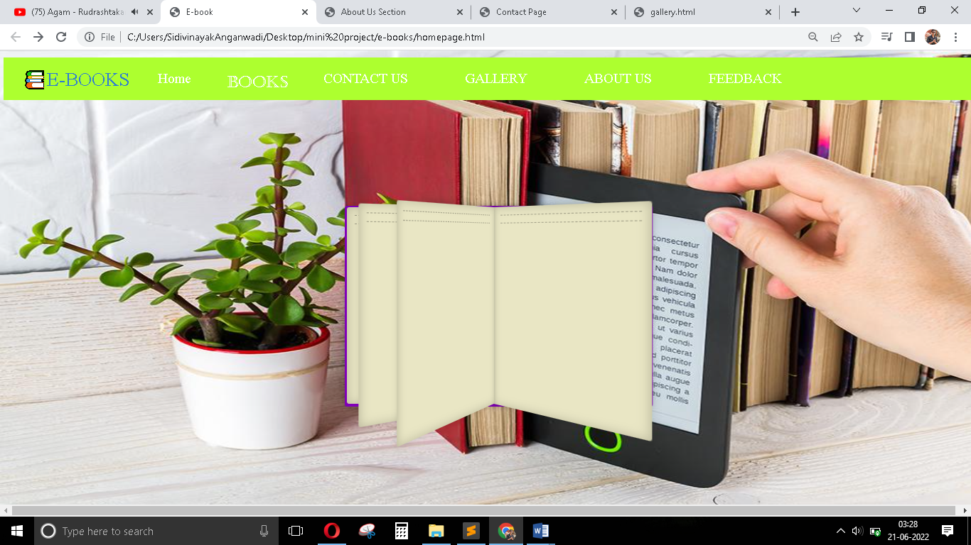

Contact :-

**OUTPUT**

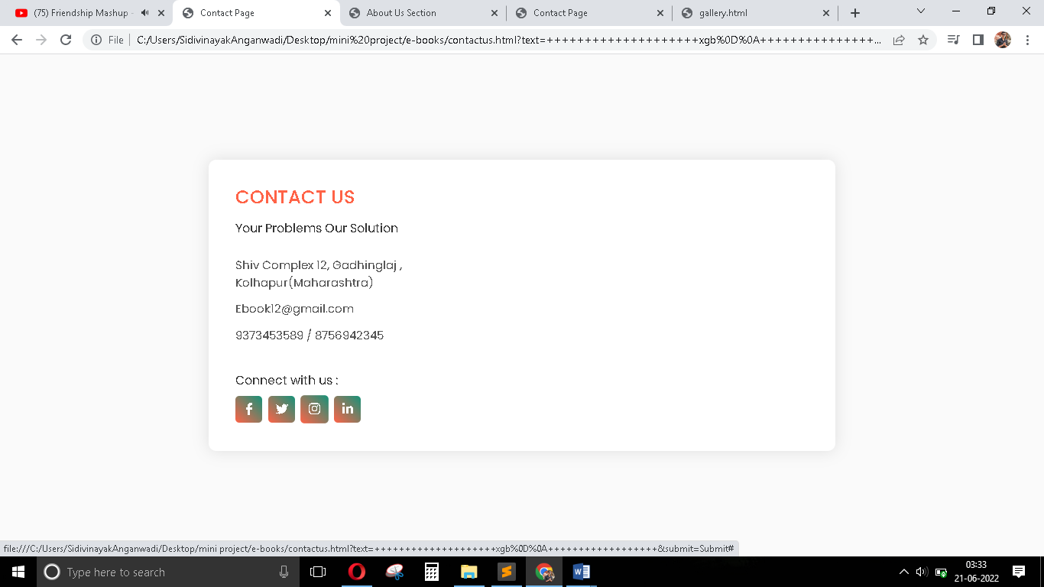

Gallery :-

**OUTPUT**

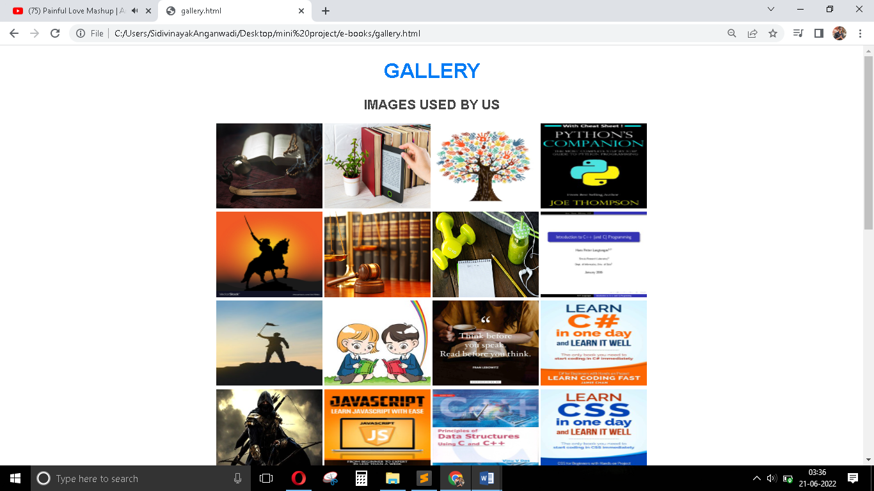

About Us :-

**OUTPUT**

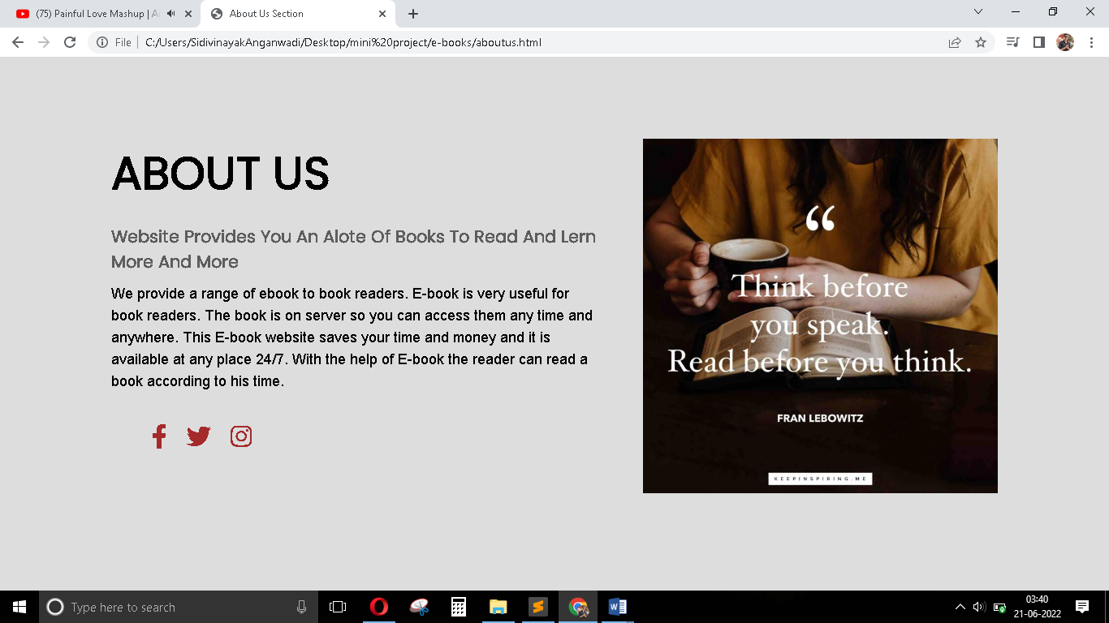

Feedback :-

**OUTPUT**

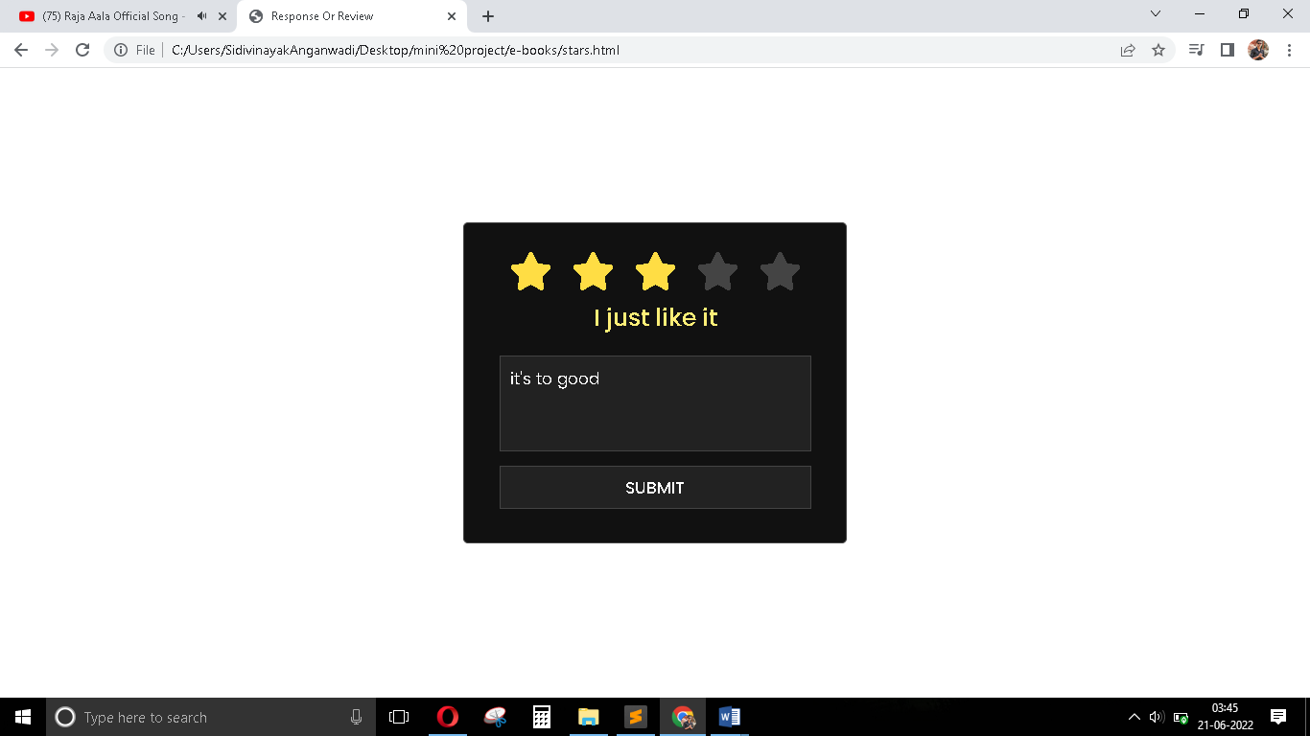

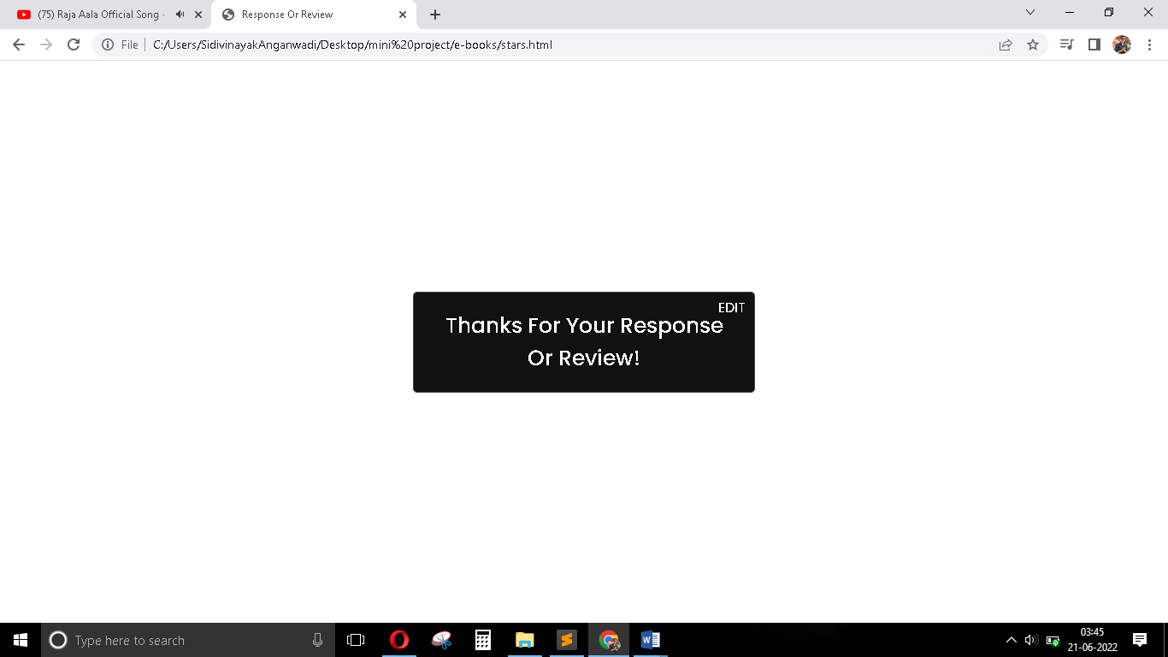

Page :-

**OUTPUT**

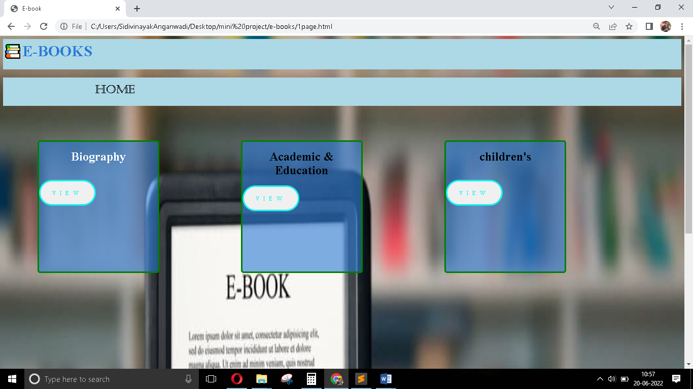

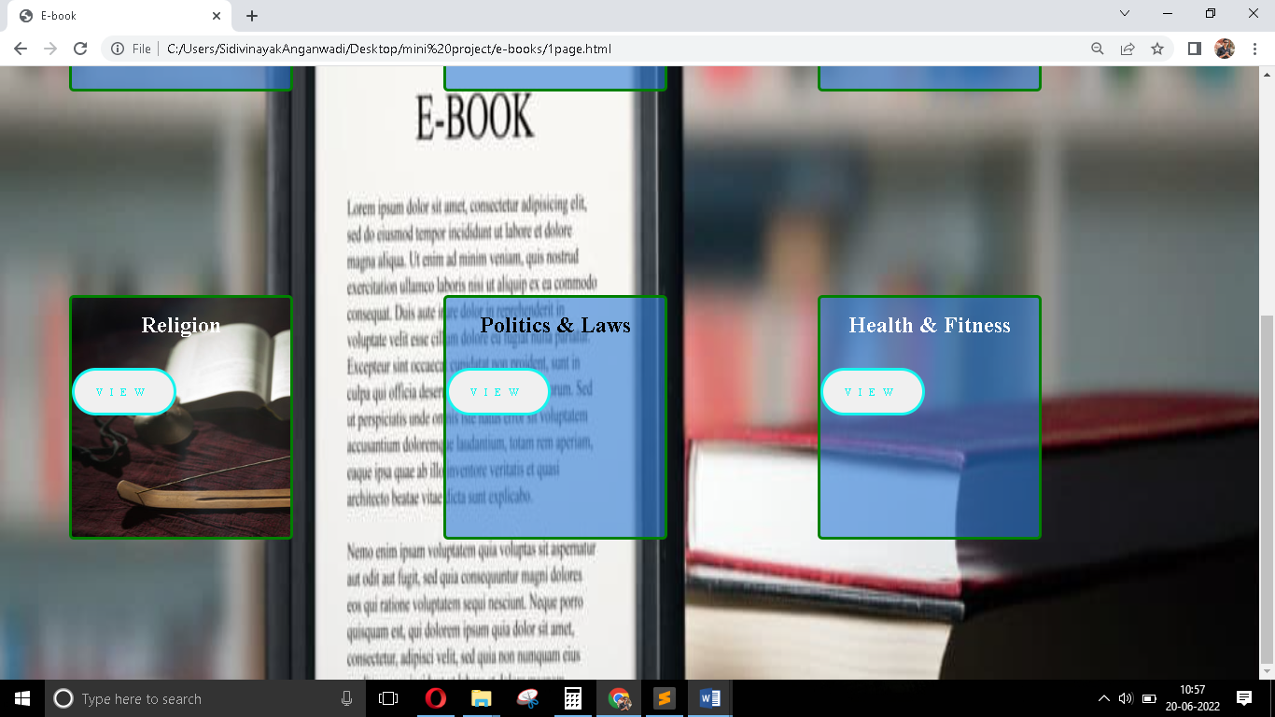

Books Page :-

OUTPUT

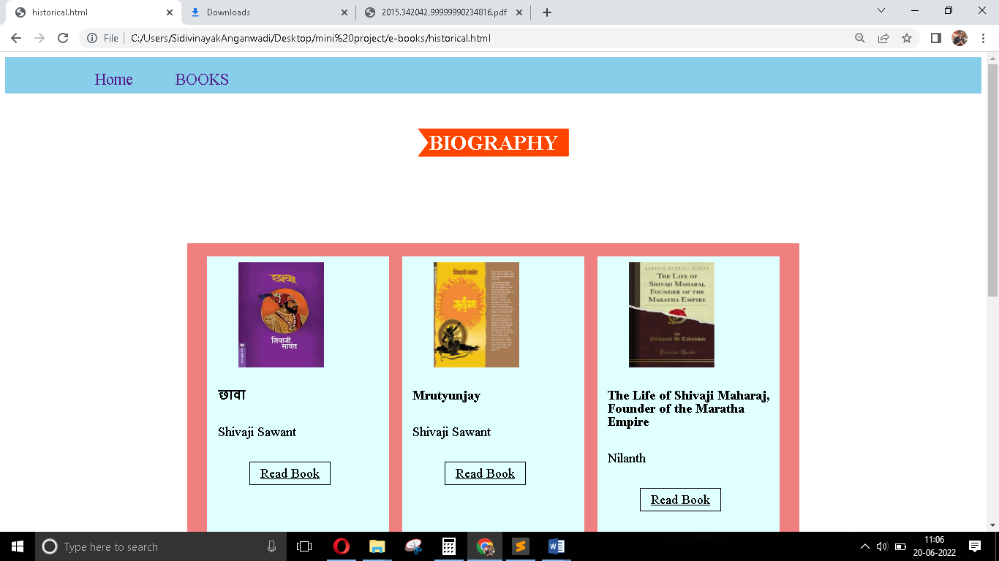

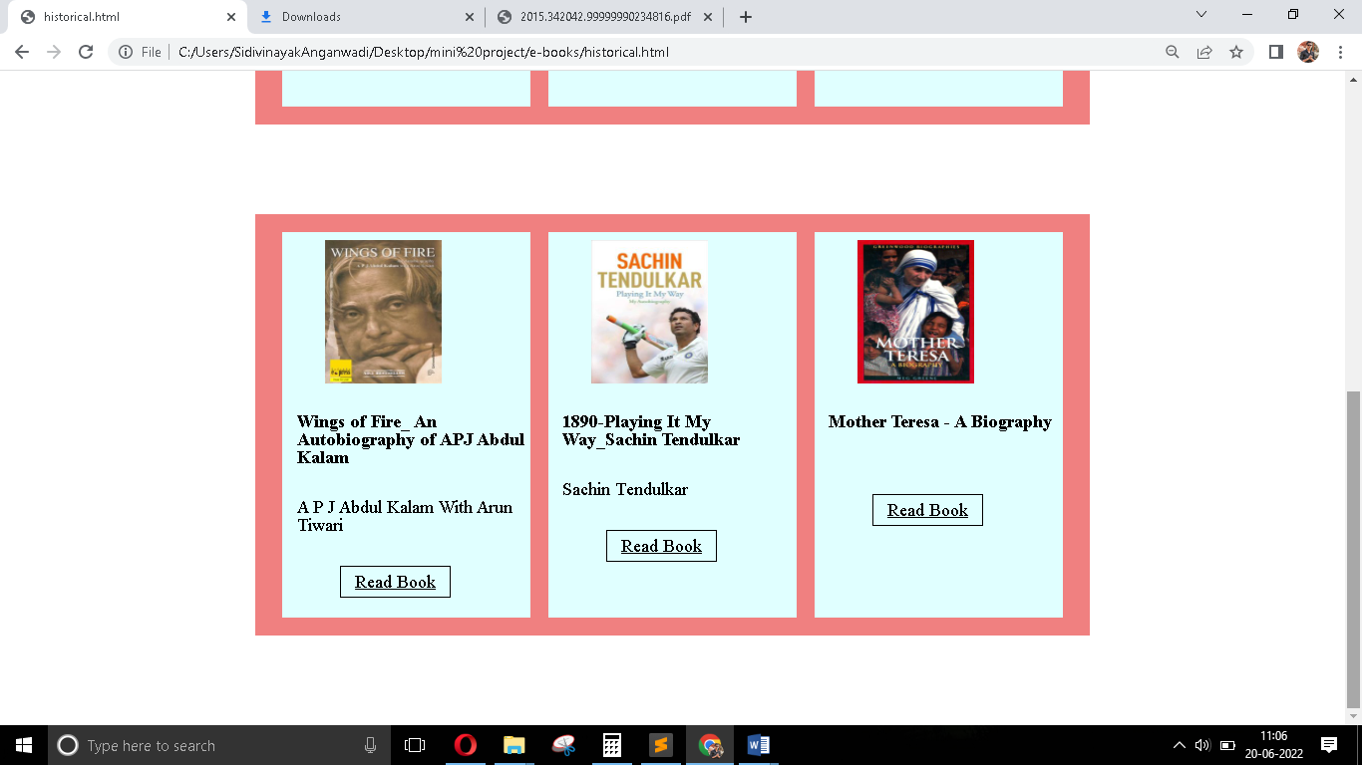

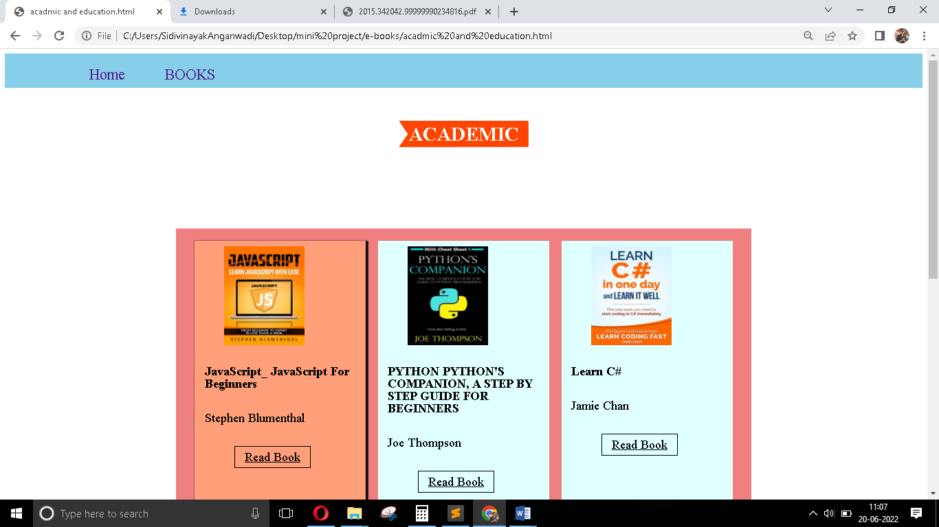

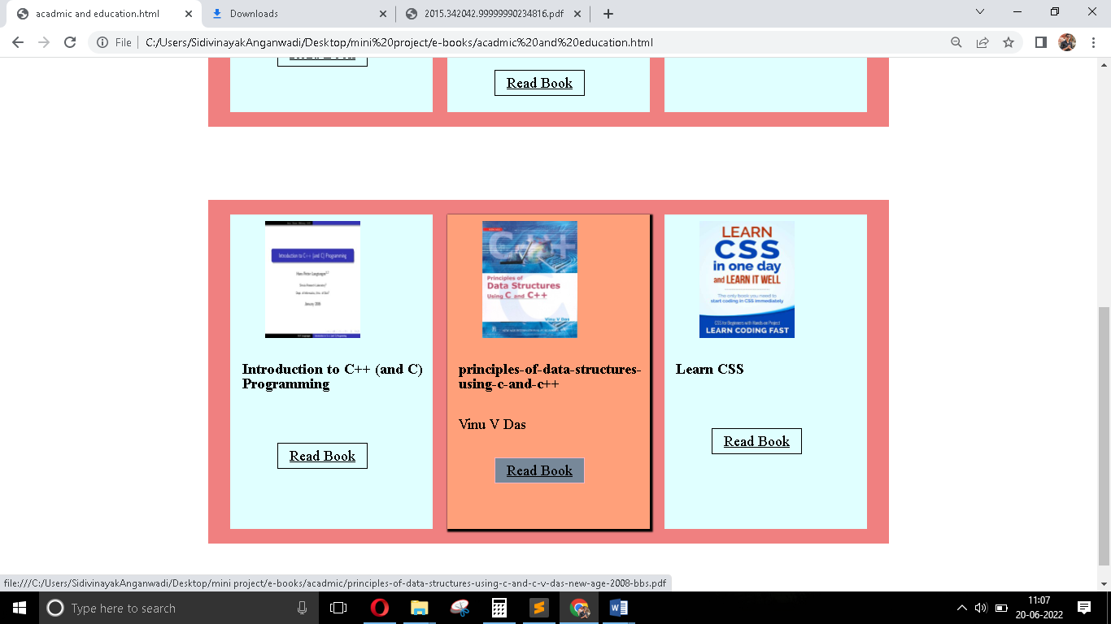

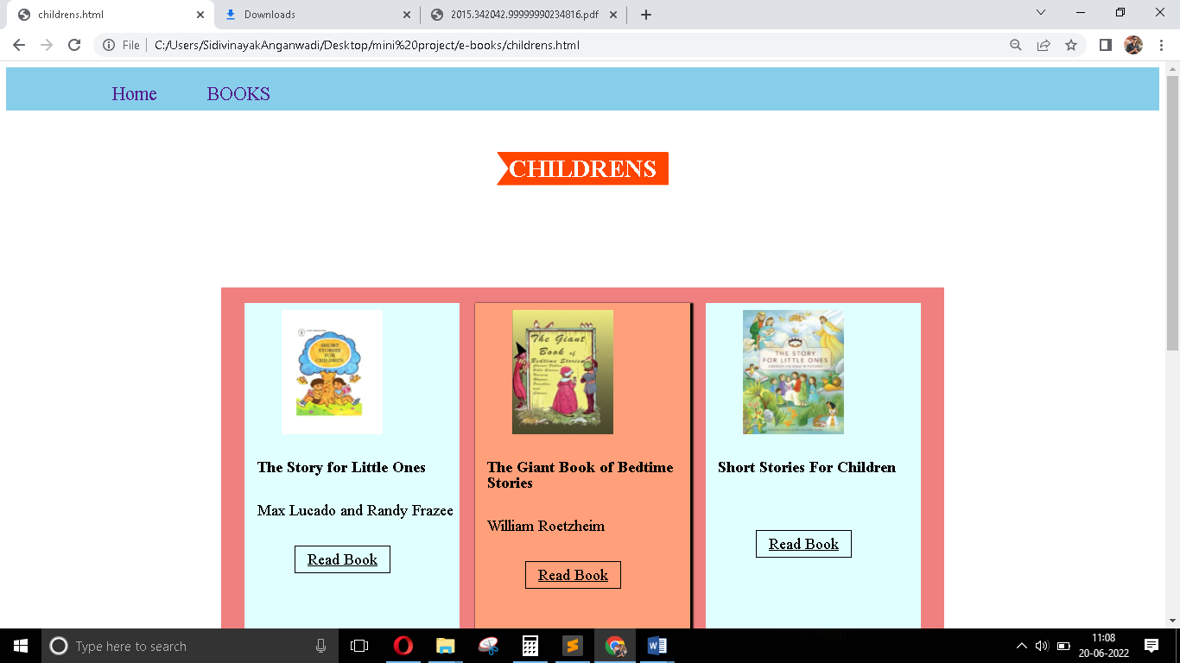

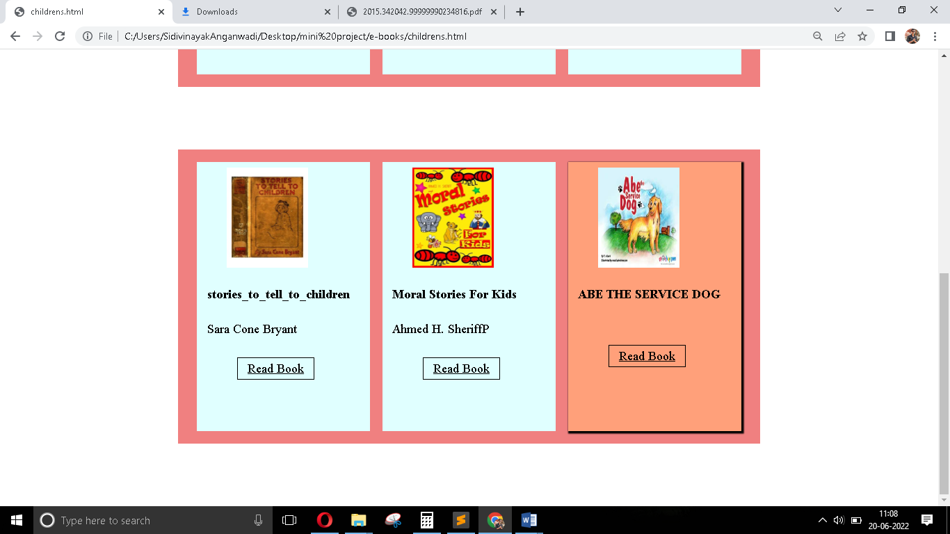

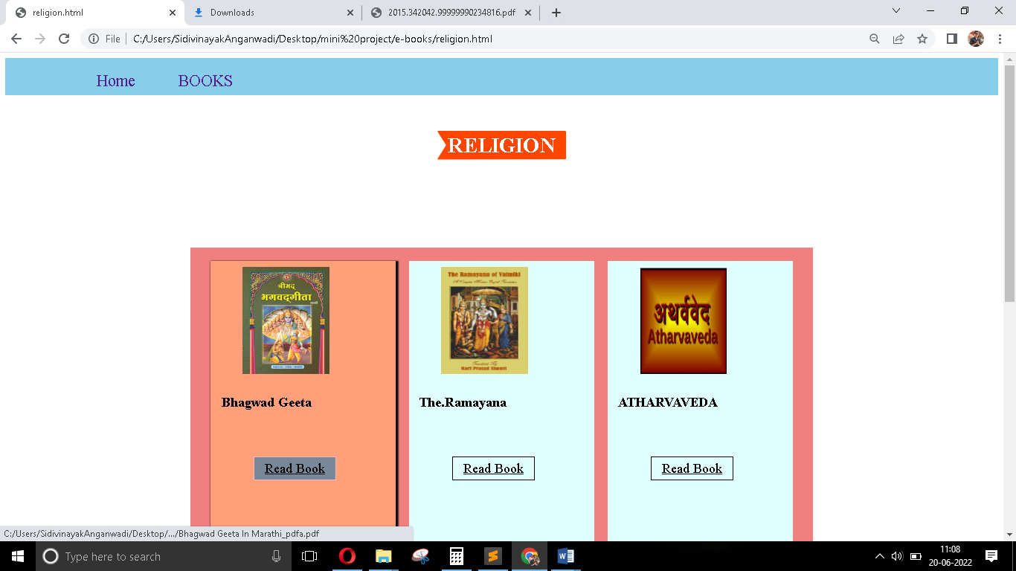

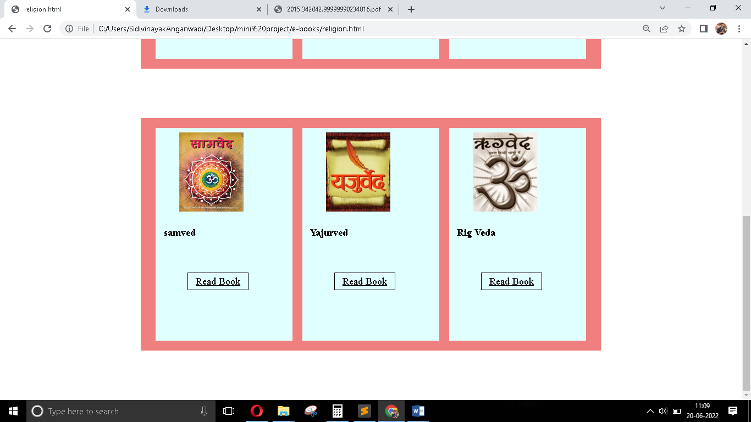

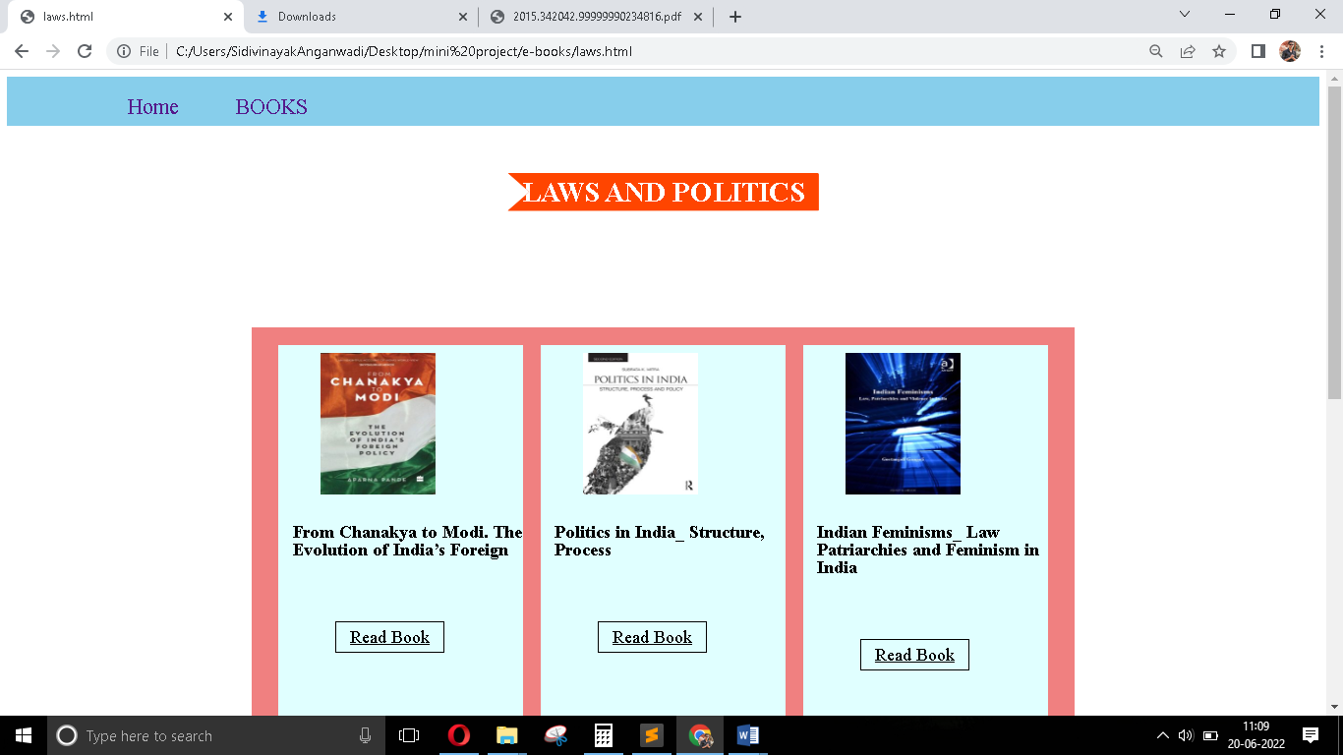

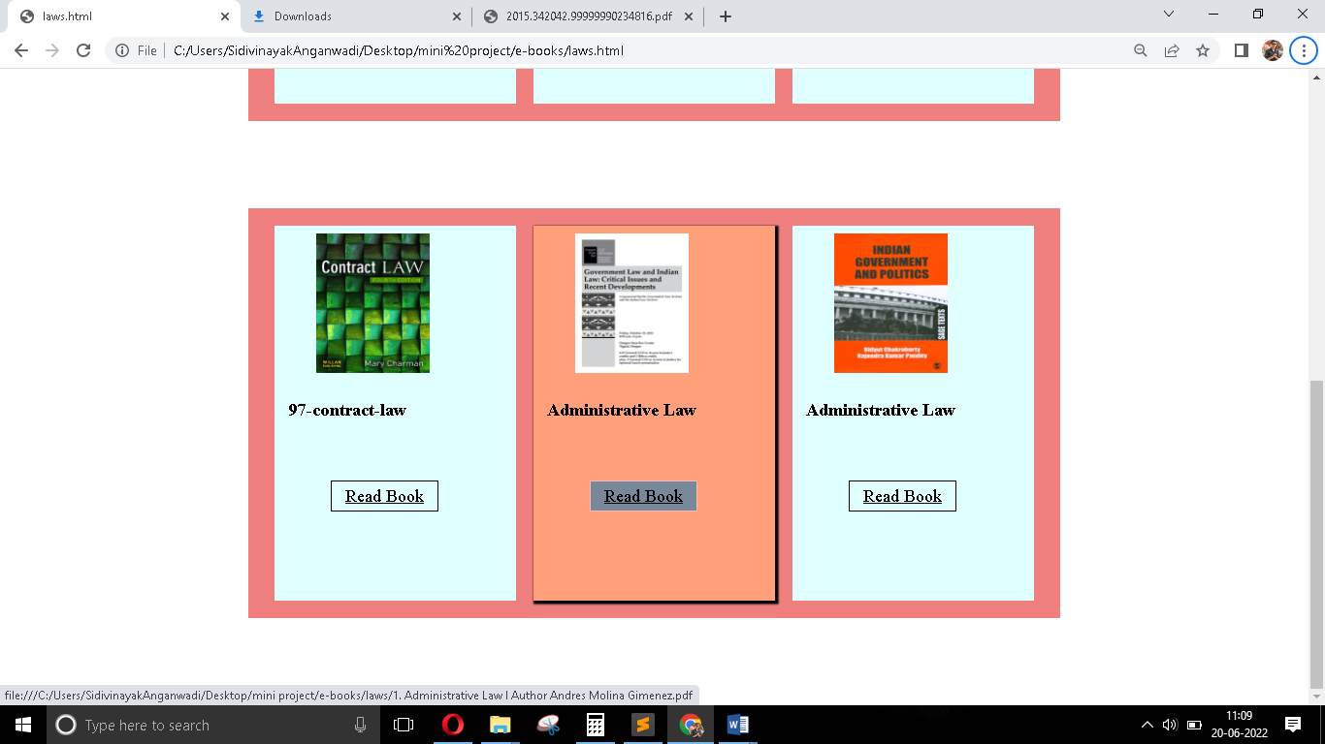

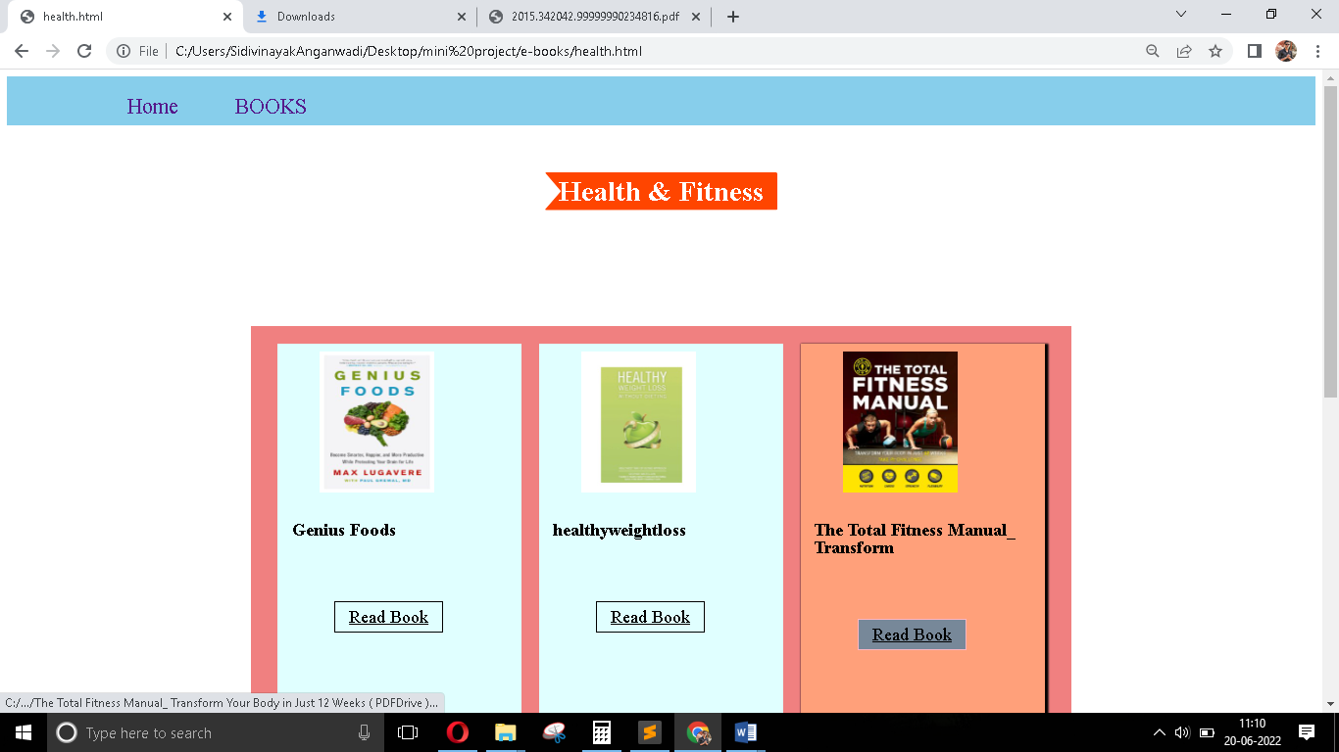

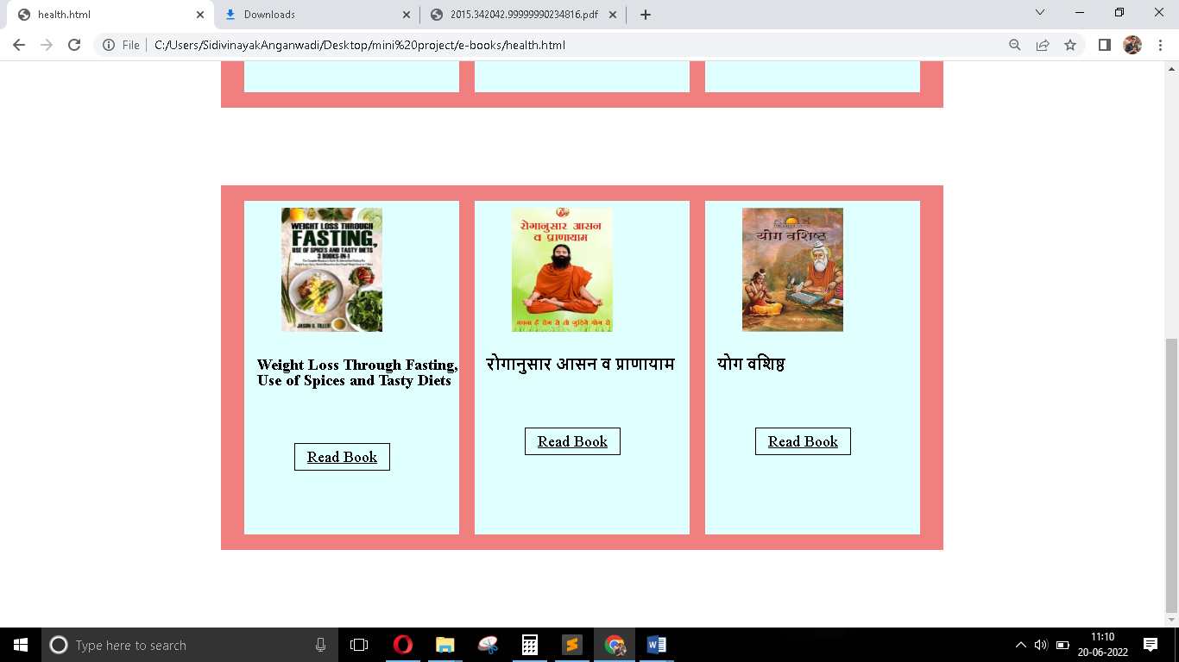

**APPLICATION**

* E-book is very useful for book readers. The book is on server so you can access them any time and anywhere.
* This E-book website saves your time and money and it is available at any place 24/7.
* With the help of E-book the reader can read a book according to his time.
* It’s user friendly platform for book readers.
* It avoid a struggle of getting books by libraries and book stalls.

# CONCLUSION

Throughout this project We, learned how to develop the project professionally. Starting from the requirement analysis, how to collect the required data for project. Development such as what type of quires should be used, from whom the correct and complete data can be collected. We also learned how to debug programs, and how to do testing of the system.

After the completion of this project ***“E-BOOK WEBSITE”*** I have gained sufficient knowledge in “Web-Development” language.

# BIBLIOGRAPHY

##### WEBSITE :-

[www.google.com](http://www.google.com/)

[www.youtube.com](http://www.youtube.com/)

### BOOKS:

### 1.JavaScript_ JavaScript For Beginners.

### 

### 2.HTML & CSS: Design and Build Web

### Sites.